ARDF
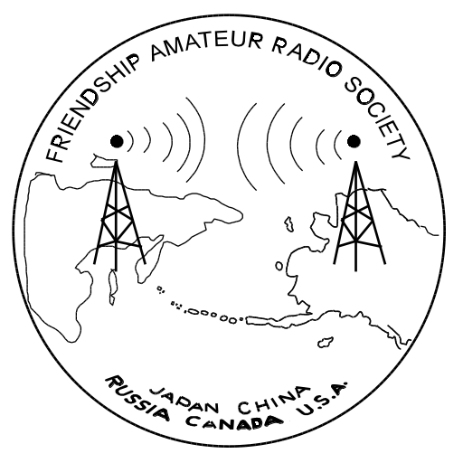
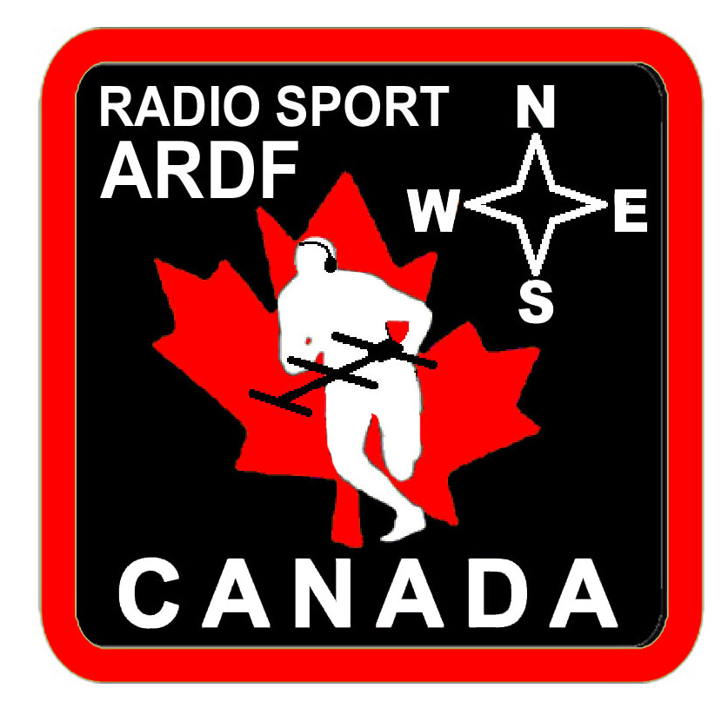
Amateur Radio Direction Finding
in
Victoria

Notes for presentation to WARA February 16, 2016.
G. D. (Joe) Young, VE7BFK <jyoung@islandnet.com>

The (power-point) slides from the Continental folk are available at:
http://nsarc.ca/hf/foxhunt0116.pdf

The VHF antenna article studying the effect of Yagi element placement on f/b is at:
https://sites.google.com/site/tapemeasureantenna/
http://qrzcq.com/call/OE8UWW

Local website including ARDF, Friendship Amateur Radio Society Canada, matters;
www.islandnet.com/~jyoung

Regular local ARDF practise sessions usually on the first and third Saturday mornings each month. Meet at Beaver Lake park, lower parking lot (filter beds), by 9:30 for setup to be ready for 10:00 start.

Textbook References

Amateur radio

Radio Orienteering - The ARDF handbook, Titterington, Williams, & Deane. RSGB 2007

Transmitter Hunting - Radio Direction Finding Simplified, Joseph D. Moell, K0OV, and Thomas N. Curlee WB6UZZ. TAB books 1987

Military History

Secret Weapon - U.S. High-Frequency Direction Finding in the Battle of the Atlantic, Kathleen Broome Williams. Naval Institute Press 1996 ISBN 1-55750-935-2

Small-Aperature Radio Direction Finding, Herndon H. Jenkins. Artech House 1991 ISBN 0-89006-420-2

More about Radar, direction finding mentioned only as being co-developed

A Radar History of World War II - Technical and Military Imperatives, Louis Brown. Institute of Physics Publishing 1999 ISBN 0 7503 0659 9

The Science of War - Canadian Scientists and Allied Military Technology During the Second World War, Donald H. Avery. University of Toronto Press 1998 ISBN 0-8020-5996-1

