Grayling Mixed Doubles Tennis Invitational 2007
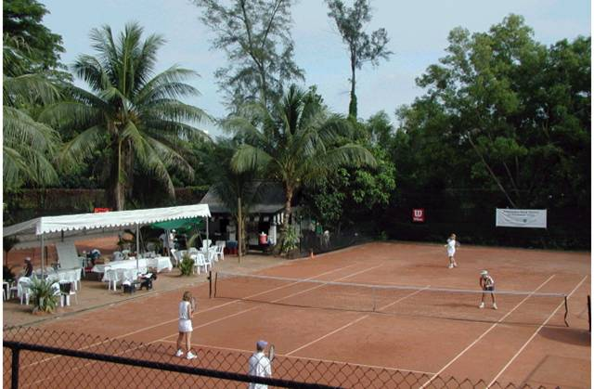

CO-SPONSORS: Fizziobel – Physiotherapy in Raffles Place.

VENUE: THE CLAY COURTS @ Winchester Rd, Alexandra Park, Singapore.
(Additional venues may be used if required)

DATES: 26th & 27th May 2007. Play will begin Saturday 8:00am. You may request for AM or PM for Saturday matches. All players must be available to play on Sunday as well.

FORMAT:

1. Schedule of matches will be posted on www.theclaycourts.com and at The Claycourts by 23rd May.
- Players will be defaulted if they are not ready to play within 15 minutes of their scheduled time.
- Davis Cup format will be used for preliminary matches and will consist of an 8 game pro set using No-Ad scoring.
- All participants are guaranteed a minimum of 3 matches.
- Saturday evening will feature social tennis from 5-7pm, followed by a buffet dinner at The Claycourts, which is included in the price. Although the Tournament will be conducted under ITF and the STA Rules of tennis the emphasis remains very much on fun!

ENTRIES: All entries are to be made on this official entry form, duly completed and accompanied by entry fees.
(Cheques made payable to: Art’s Pro Tennis Services) Entries should be sent to: Art Hobbs c/o Blk 45 Telok Blangah Dr. #02-139, Singapore 100045 or drop them off at The Clay Courts before 6pm, 20th May 2007.

Please e-mail: art_hobbs@hotmail.com or joang@starhub.net.sg if you need further details

PLAYER INFORMATION
Name & Signature | Rating | Address | Email | Home tele | Mobile
Gentleman:

Lady:

ENTRY FEE: S$100.00 / Team

Combine your tennis ratings to decide which division you best represent. This will help determine the correct seeds for the Davis Cup Draw.

Gold Division O Silver Division O Bronze Division O Saturday AM or PM
(8.5 & above) (6.5 –8.0) (6.0 & below)

In signing to enter the tournament, you confirm that you have read and understood the rules and regulations governing the tournament and agree to abide by them. You also agree not to hold the Organizing Committee, Grayling Asia Pte Ltd, Fizziobel or Art’s Pro Tennis Services responsible for any death, injuries, loss or mishaps that you may sustain arising out of your participation.

